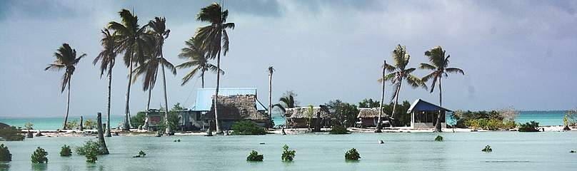
Debate Team 1
.

Climate Change Scepticism
You agree with scientists, that climate change is happening and caused by humans, and that we need to do something about it NOW.

Climate Change Facts
FACT 1
FACT 2
FACT 3
The observed atmospheric increase in the global CO₂ concentration since 1750 is caused by human activities.

Present-day concentrations of atmospheric CO₂ are higher than at any time over the past 800,000 years
It is extremely likely that human activities caused most of the observed increase in global temperature from 1851 to 2020.
Pg.1

This photograph shows the Solomon Islands which are only just above sea level.
Climate Scientists study the Earth’s climate system, which includes the atmosphere, the oceans, ice, plants and everything else which has an impact on the weather and climate and is affected by it. They try to work out how things have changed in the past, and what might happen in the future.
The Future
Even if we stop emitting greenhouse gases now, the climate will keep changing for decades, because it takes the Earth a long time to adjust and recover.
It is the changes in extreme weather events (wind, rain, heat waves etc.) that will cause people the most problems.
We don’t know how societies will develop over the next century, or exactly how the climate will change. If we want to reduce the impact of climate change we need to start preparing now. For example, it takes tens of years to change how a country produces its electricity.
It is easier to adapt to small changes in climate than to large ones.
The natural world can’t always adapt in the same way that people can.
Your mission is to gather evidence and information based on facts to SUPPORT the argument that of climate change is caused by people and should be prevented. You need to look at the facts carefully and organize them in a way that you can present it clearly to your audience. Remember, a debate means that you will be taking part in an open discussion. You must be prepared to argue your points, using evidence to support what you are saying and to contradict the opposing team!

You should consider:
- The link between CO₂ in the atmosphere and temperature rise.
- Sea level rise.
- Extreme weather and global events
- The rate of current climate change in comparison to past records

Other things to think about!
- Why might some people not want us to reduce how much oil and gas we use?
- Do you think the sceptics would think differently if they knew that climate change was going to cost them their homes or jobs?
- What is the worst that could happen if we acted to prevent climate change?
- Some countries will be affected more by climate change than others, and some can afford to deal with it better than others.
- Actions that we take now will have an impact on the climate in decades to come.
Things to remember:
- The other team will be arguing that climate change is not caused by humans, or that we don’t know enough about what’s going to happen to make it worth doing anything, or that people will adapt and cope as the climate changes. You may like to divide your team into three to research arguments against each of those points.
- Even if you don’t believe that climate change is caused by humans and that we need to try and prevent it, try to think from a scientist’s point of view!
- Back up your points with evidence and statistics.

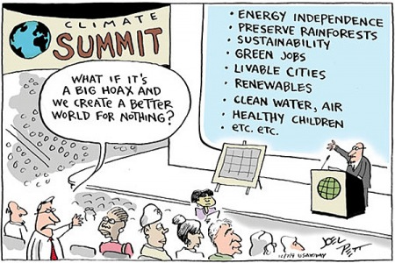

You might find these links helpful to gather information;

https://climatekids.nasa.gov/kids-guide-to-climate-change/
www.skepticalscience.com
http://www.bbc.co.uk/news/science-environment-26814737
https://climate.nasa.gov/climate_resources/300/video-climate-spiral-1880-2022/
climate.nasa.gov/evidence/
https://xkcd.com/1732/
http://www.bbc.co.uk/news/world-europe-19508906
https://www.bbc.co.uk/news/science-environment-24021772
http://www.isthishowyoufeel.com/this-is-how-scientists-fe
Psst! Need a hint?
If you have an idea of the arguments that you think the other team might use, then you can be prepared with a response to that argument. (This does not mean that you should spy on the other team! Do your research!)

